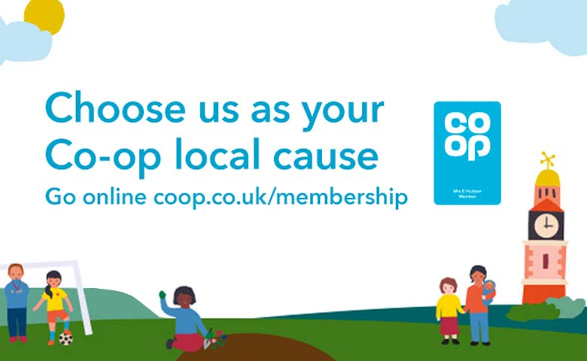

Great News!! Lovel End Nursery has been selected to be one of Co-op Local Community Funds for this year.
The Co-op Local Community Fund supports projects across the UK that our members care about.
Every time our members buy selected Co-op branded products and services, we'll give local causes a helping hand.
If you are a Co-op member please visit https://membership.coop.co.uk/causes where you will be able to select us as your local cause

Thank you for supporting Lovel End Nursery

About this cause
We're a community-run, non-profit pre-school aiming to enhance the development and education of children aged 3–5 years. We offer a safe and stimulating environment for children under school age through a varied curriculum aiding a smooth transition to school. We support and encourage families to be involved in their child's education and help each one develop confidence and self-respect.

Mental wellbeing
We would like a professional to give our local children weekly yoga lessons. Young children practising yoga experience a decrease in stress, have fewer behaviour issues and better overall learning.

When you buy selected Co-op products and services, 2p for every £1 spent goes into your membership account. And we’ll split the same between like-minded organisations and local causes.
Please choose this cause

You can only support one cause at a time

How this cause brings people in the community together
The children have had such a turbulent year with the Covid-19 pandemic and we've already seen an impact on their social skills, anxiety and mental wellbeing. This would provide them with the tools and skills to manage their anxieties, to aid home-life and increase the strength of their relationships while also allowing them to share these skills with their families, friends and relatives.

